AI FitTrack Requirement Analysis
  - Phase 2

This document converts the official requirements into verifiable backend requirements and maps each one to the uploaded implementation and supplied evidence.
Field | Value
Project | AI FitTrack
Submission | SmartBridge Naan Mudhalvan
Team ID | SWTID-2026-8100
Team size | 4
College | DRBCCC Hindu College
Department | B.Sc. Computer Science with Artificial Intelligence
Academic Year | 2024–2027
Faculty Guide | Prof. D Saraswathy
Submission Date
Team Leader | Parthiban M (NM ID: 28538B1DB05060E8D804CDAA88169909, Reg: 222401226)
Team Members | Naveen J (NM ID: 53C2DC1753C6DFDAF8649841B4630C80, Reg: 222401223); Nidesh N S (NM ID: FDE55A8DA9135F6AB7347C01AD1B8A17, Reg: 222401224); Nithish Kumar P (NM ID: BFBD9AD8CEC72229F374877DB82CC0B8, Reg: 222401225)
Project scope | Backend-only REST API
Technology | Node.js, Express.js, MongoDB, Mongoose, JWT and Google Gemini AI
Source baseline | Latest uploaded backend ZIP and supplied verification evidence
Document status | Submission-ready verified technical documentation with complete academic details

Prepared for academic evaluation. Secrets, credentials, private environment files and unverified claims are excluded.

Document contents
1. Requirement sources and scope
2. Actors and workflows
3. User stories
4. Functional requirements
5. Nonfunctional requirements
6. Technology stack
7. Data rules
8. Traceability and open items

Requirement sources and scope
The official AI FitTrack document and the uploaded backend agree on the required backend domain: secure user authentication, user-owned workout management, workout search, MongoDB persistence and Google Gemini AI guidance. The official document also mentions possible frontend consumers, but this submission is intentionally backend-only.
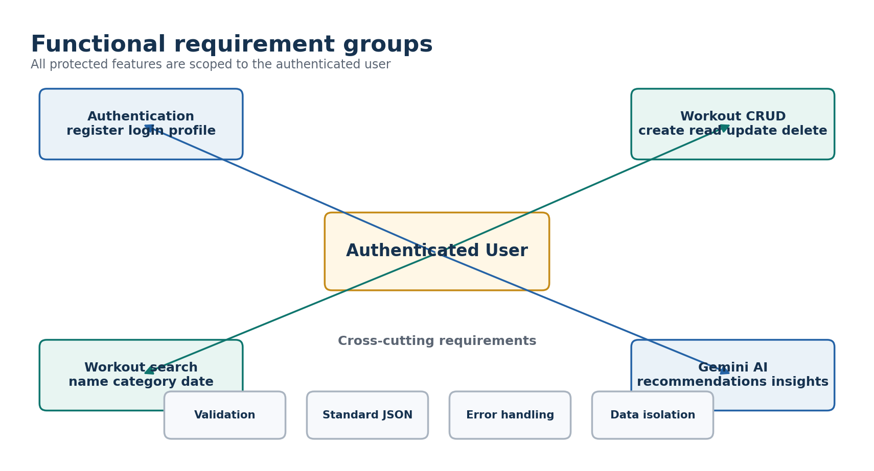
Figure 1 Functional requirement groups and cross-cutting controls

Primary actor
The only implemented role is an authenticated user. Public operations are registration, login and email-availability checking. Profile, workout and AI operations require a valid JWT. No administrator role or team-management feature exists in the uploaded source.

End-to-end user workflow
- Register with a valid name, email and password.
- Log in and receive a Bearer JWT.
- Use the token to retrieve the profile and access protected routes.
- Create, list, retrieve, update, search and delete owned workout records.
- Request a Gemini workout plan using age, fitness goal and experience level.
- Request fitness insights using submitted statistics or owner-scoped MongoDB statistics.

User stories and acceptance criteria
ID | User story | Acceptance criterion | Priority
US-01 | As a visitor, I can register and log in securely. | Valid details return a safe user and JWT; duplicate or invalid details are rejected. | High
US-02 | As an authenticated user, I can view my profile. | A valid Bearer token returns only the current safe user fields. | High
US-03 | As an authenticated user, I can manage my workout records. | Create, list, retrieve, update and delete operate only on the token owner's records. | High
US-04 | As an authenticated user, I can search my history. | Name, category and valid UTC-date filters return only matching owned workouts. | High
US-05 | As an authenticated user, I can request a workout recommendation. | Validated age, goal and experience produce a structured general-fitness response. | High
US-06 | As an authenticated user, I can request fitness insights. | Submitted or database-derived statistics produce structured insights without exposing another user. | High

Functional requirement traceability
ID | Requirement | Verified status
R1 | Layered MVC-style backend with routes, controllers, models, middleware, services and config | Implemented
R2 | Node.js and Express.js REST API | Implemented
R3 | MongoDB and Mongoose connection management | Implemented
R4 | Users and workouts collections | Implemented
R5 | User schema with validation, unique email, bcrypt and timestamps | Implemented
R6 | Workout schema with owner, fields, validation and timestamps | Implemented
R7 | User registration and duplicate handling | Implemented and live-evidenced
R8 | User login and JWT issuance | Implemented and live-evidenced
R9 | Protected user profile | Implemented and live-evidenced
R10 | Create owner-scoped workout | Implemented and live-evidenced
R11 | List workout history | Implemented and live-evidenced
R12 | Search by name, category and date | Implemented and live-evidenced
R13 | Get workout by identifier | Implemented and live-evidenced
R14 | Partial workout update | Implemented and live-evidenced
R15 | Delete workout and deny later retrieval | Implemented and live-evidenced
R16 | Gemini workout recommendation | Implemented and live-evidenced
R17 | Gemini fitness insights using submitted or database statistics | Implemented and live-evidenced
R18 | Standard JSON responses and centralized error handling | Implemented
R19 | Request and schema validation | Implemented and automated-test evidenced
R20 | JWT middleware and fresh user lookup | Implemented and automated-test evidenced
R21 | Password protection and response redaction | Implemented and live-evidenced
R22 | Per-user data isolation | Implemented and automated-test evidenced
R23 | Postman, automated, smoke and Atlas verification | Evidence supplied
R24 | Environment-based MongoDB, JWT and Gemini configuration | Implemented with example only

Nonfunctional requirements
Category | Requirement | Implementation evidence
Security | Hash passwords, protect routes, isolate records and keep secrets outside source control. | bcrypt cost 12, JWT middleware, owner-scoped queries, .gitignore and .env.example.
Reliability | Fail clearly when database, token or AI configuration is unavailable. | Database-gated startup, fail-fast JWT secret check, centralized error middleware and normalized Gemini errors.
Maintainability | Separate routing, business logic, data models and external services. | routes, controllers, models, middleware, services, config and utils folders.
Performance | Bound list results and avoid uncontrolled external retry loops. | Workout limit clamped to 1-500; Gemini retry count and delay are bounded.
Interoperability | Use HTTP and JSON for frontend or mobile integration. | Express REST endpoints, CORS and standardized response envelope.
Testability | Support isolated automated testing and live API verification. | Node test suites, Supertest, MongoDB memory server, smoke scripts and Postman collection.

Technology stack
Component | Implemented technology | Purpose
Runtime and API | Node.js 20+ and Express.js 5 | REST routing, middleware and server lifecycle
Database | MongoDB with Mongoose 9 | Validated users and workout persistence
Authentication | JWT and bcryptjs | Signed access tokens and password hashing
Artificial intelligence | Google Gemini through @google/genai | Structured workout recommendations and fitness insights
Verification | Node test runner, Supertest, MongoDB Memory Server and Postman | Automated, isolated and guided API testing

Software and execution requirements
Item | Required baseline
Runtime | Node.js 20 or later, because the uploaded package.json declares node >=20.0.0.
Package manager | npm with dependencies installed from server/package-lock.json.
Database | MongoDB Atlas or a compatible local MongoDB deployment.
API client | Postman, curl or another HTTP client.
AI provider | Google Gemini API access configured through GEMINI_API_KEY.
Development editor | Visual Studio Code or equivalent.

Data validation rules
Object | Field | Implemented rule
User | name | Required; trimmed; 2 to 80 characters.
User | email | Required; normalized lowercase; regular-expression validation; unique index.
User | password | Required; minimum 6 characters; bcrypt hash; excluded from normal queries and serialized output.
Workout | workoutName | Required; trimmed; 2 to 120 characters.
Workout | category | One of Cardio, Strength Training, Yoga, Running, Cycling or Walking.
Workout | duration | Number from 1 to 1440 minutes.
Workout | caloriesBurned | Number from 0 to 20000.
Workout | workoutDate | Required valid date.
AI recommendation | age | Whole number from 13 to 100.
AI recommendation | goal and experience | Case-insensitive values from implemented allow-lists.
AI insights | statistics | Bounded numeric metrics, or useDatabaseStats true.

Requirement interpretation notes
- The official software list contains a stale sentence about posts, categories and comments. The same document's schema tables and the source correctly use users and workouts.
- The official document shows Node.js 16 or above, while the delivered package explicitly requires Node.js 20 or above. The implementation requirement takes precedence for execution.
- The implementation accepts compatibility aliases for experience and averageDuration while retaining canonical API names.
- Search is supported on both GET /api/workouts and GET /api/workouts/search.
- The public email-availability endpoint is an implemented extension beyond the core official endpoint list.

Items requiring student confirmation
Pending item | What to provide
Repository | Insert the final public GitHub repository URL after upload.
Deployment | Insert the deployed API base URL if the evaluator requires a hosted demonstration.

